Online Cake Ordering System
Project: Sweet Crumbs | Technology: HTML, CSS, JavaScript (localStorage)

Aim
To build an online cake ordering application with product filters, cart, delivery address and order tracking.

Algorithm
- Start: load cakes, cart and orders from localStorage.
- Display products; apply filters (flavour, price, category).
- Add cakes to cart; update quantity; compute subtotal.
- At checkout enter delivery address and date; place order.
- Order moves through stages: Placed → Baking → Out for delivery → Delivered.
- User tracks order status; admin adds/edits products and updates status.
- Save to localStorage. Stop.

Result
The Online Cake Ordering System was implemented successfully using HTML, CSS and JavaScript. All modules (login, role-based pages, data entry, search/booking and admin management) work correctly in the browser, and data persists using localStorage.

Implementation (Output Screenshots)
Home page
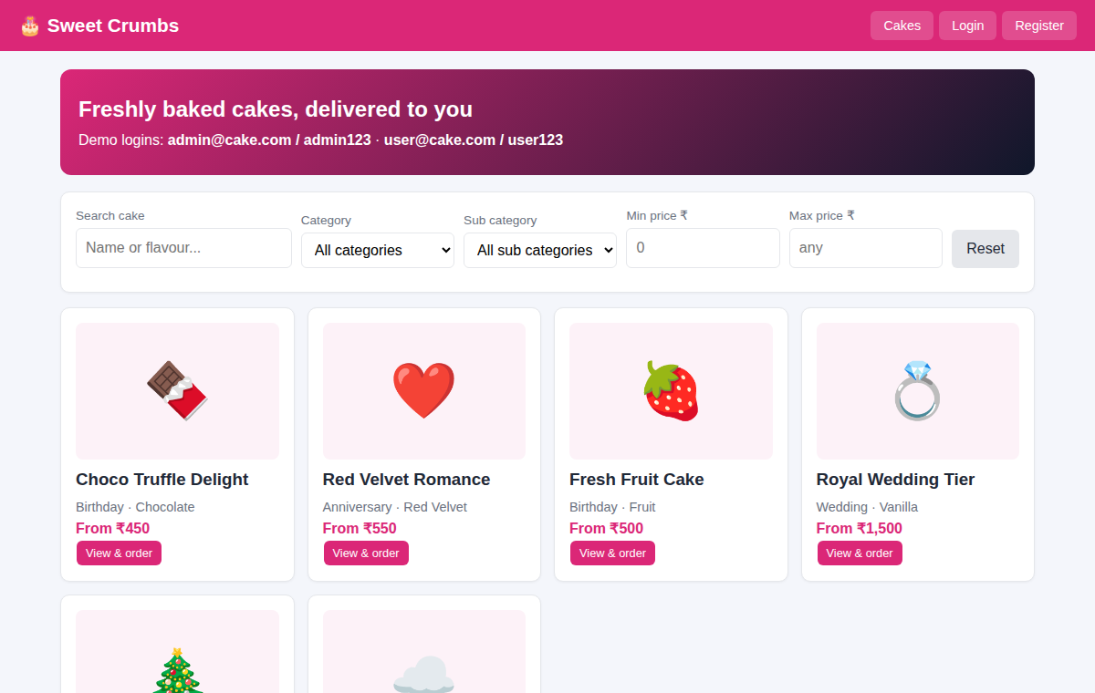
After login (admin / dashboard)
